Images Notes

Images
The programmer would like to place and image onto their window. The first thing the programmer would want to do is get several images. The programmer would then create a window and a JFrame and a JPanel.
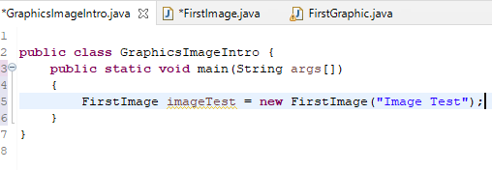
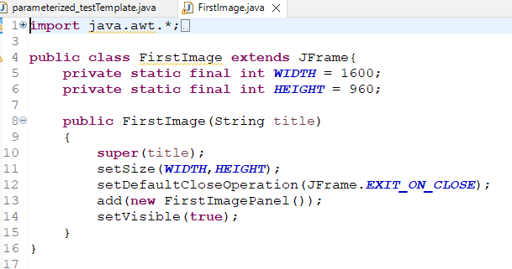
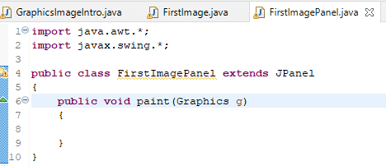
The programmer needs to place the images into the project but not into the src folder. Much like text files, the programmer wants the images available to the project. The programmer would right click GraphicsIntro and select import. Then they would press the arrow by the general folder and select file system. The programmer would then browse the directory for the folder where the images are stored and click that folder. Once it is clicked the images that are available will be shown.
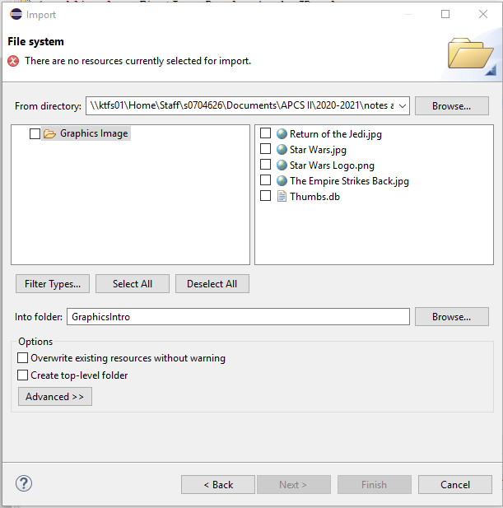
The programmer would then select all the images they want and click finished. The images will then be placed in the GraphicsIntro project but outside of the src folder.
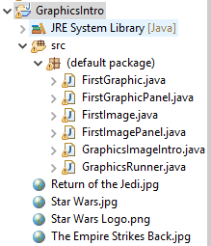
The programmer would like to load all the necessary files into the program. They will use BufferedImage to store these pictures. The programmer could load them in an ArrayList, an array, a Map, or just individually. To simplify, the programmer will put them into individual BufferedImages. BufferedImage is a class that is imported from the awt.image library. This means that
import java.awt.image.*;
must be used to use the BufferedImage data type. The programmer could see all the possible methods that go with BufferedImage by looking at the API. The programmer will also be using File and ImageIO, which calls for the following to be imported:
import java.awt.*;
import java.awt.image.*;
import javax.imageio.ImageIO;
import javax.swing.*;
import java.io.*;
With the inclusion of import java.io.*; the programmer will have to use throws IOException or do a try catch.
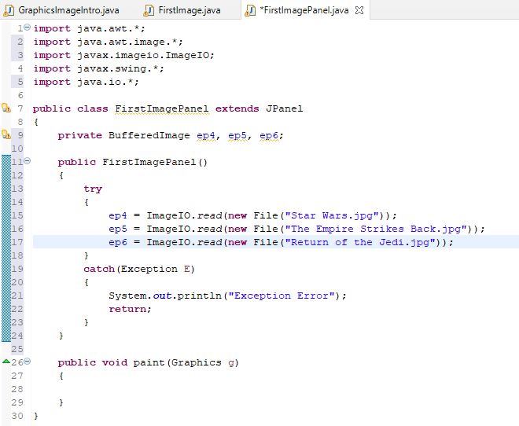
From the code shown above, the programmer used the try catch technique to avoid Exception errors. For each BufferedImage, a call to the ImageIO class is used and the read method is employed. A new File object is created and the file name is called. The file is located in the project, so there is no need to hunt through folders looking for the file.

drawImage(image img, int x, int y, int width, int height, ImageObserver observer)
The drawImage receives the image, the (x,y) coordinate of the upper left cornere, the width and the height of the rectangle the image should be placed inside, and observer is something that the programmer will set to null. However, when the programmer has time, they should explore what an ImageObserver does.
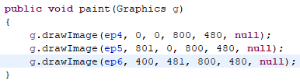
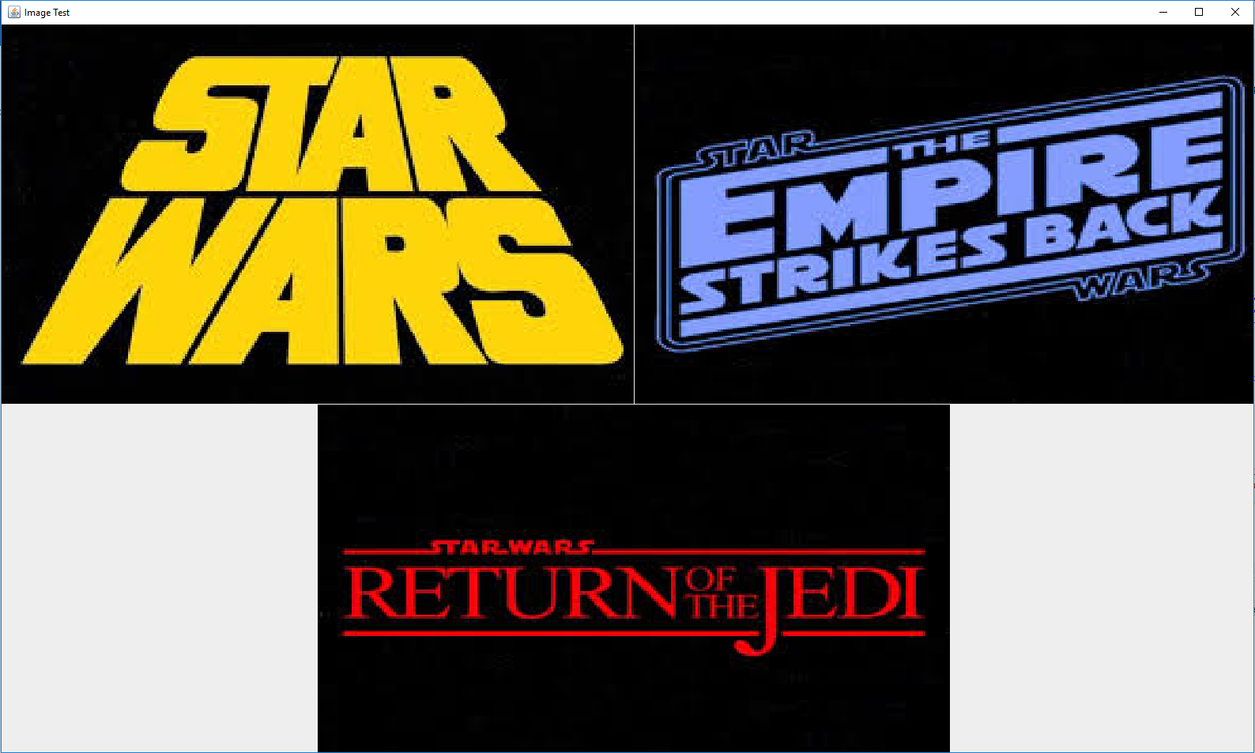

JARing a file with images
The programmer will want to make a few changes with their program if they intend to JAR up a file with images in order for the images to work. The programmer will want to create a package inside of the src folder called images by right clicking on src, choosing new, and selecting package. The programmer should give the package the name of Image for the package.
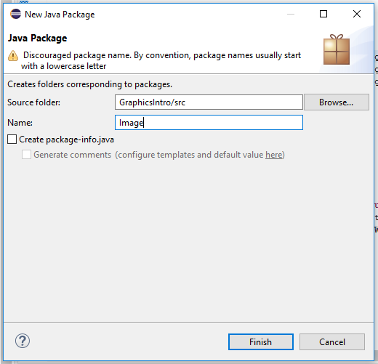
The package will appear inside of the src folder. Move all pertinent images into that folder.
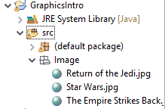
The programmer would then go into the FirstImagePanel and change the read from:
ep4 = ImageIO.read(new File("Star Wars.jpg"));
ep5 = ImageIO.read(new File("The Empire Strikes Back.jpg"));
ep6 = ImageIO.read(new File("Return of the Jedi.jpg"));
to
ep4 = ImageIO.read(FirstImagePanel.class.getResource("/Image/Star Wars.jpg"));
ep5 = ImageIO.read(FirstImagePanel.class.getResource("/Image/The Empire Strikes Back.jpg"));
ep6 = ImageIO.read(FirstImagePanel.class.getResource("/Image/Return of the Jedi.jpg"));
new File is replaced with [the name of the Panel class].class.getResource(“/Image/[name of image]”)
Now the programmer is ready to JAR up the file. When JARing up the file, making sure to select the Package required libraries into generated JAR which is currently the second Library handling button. The programmer now has a working JAR file that will run with images without using the IDE.
A special thank you to Anthony Pham for creating a video that explains how to JAR up a program with files.

